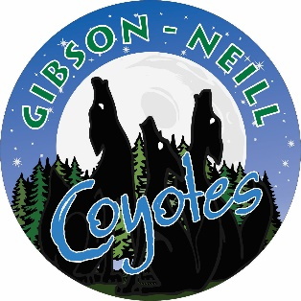
Gibson-Neill Memorial Elementary School

Dear Future Gibson-Neill Student,

Save the date!

Wednesday, May 24th from 2 pm – 3 pm

You are invited to come visit our school, spend time in the Kindergarten classrooms, meet some teachers, and even meet some of your new classmates!

Parents are also invited to come to the school to meet the teachers and view a presentation. Our Principal and Vice-Principals will also be there to answer any questions you may have.

We are all excited to meet you!

